

Application Form
Online School

Mt Hobson Academy –
The unique approach for Years 1-13

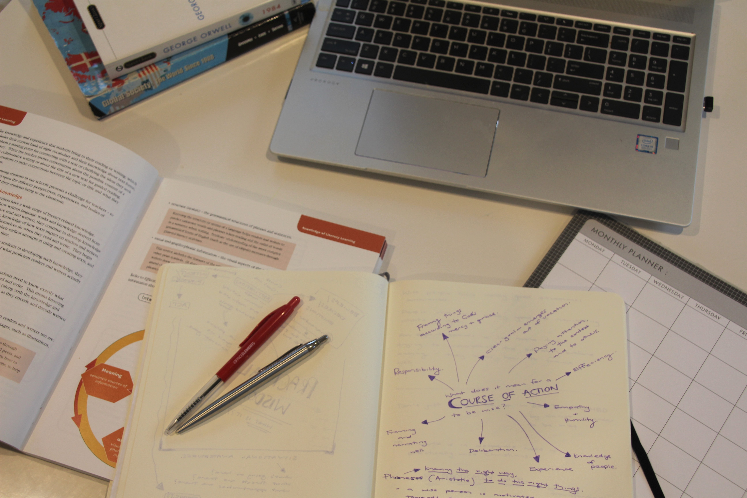

Pathway to Opportunity



Admissions

Procedure for Admission:

Students can apply to enter the academy at any level. Applications must be made on the official application form (contained within this document) or available on the Mt Hobson Academy website (www.mthobson.school.nz).

Interviews:

On receipt of the application, both the student and the parent(s) will be invited to attend an online meeting with Alwyn Poole.

Supporting documents:

Please include the following with the completed application form:

- A copy of the student’s last school report.
- A passport sized photograph.
- The application fee of $190 for one student or $300 for 2 or more from the same family (Please note, this fee is non-refundable.)
- Bank account for payment 02 0192 0161844 00 Villa Education Trust

Please forward your completed application to:

Enrolments -Online School
Mt Hobson Academy
Villa Education Trust
P.O. Box 74276
Greenlane
Auckland 1546

Or email directly to Alwyn Poole alwyn.poole@gmail.com

Application form Online

Mt Hobson Academy



Given names …………………………………………………………

Family name ................................................ ……………………..

Date of Birth............................................... Nationality...........................................................

Ethnic Group.............................................. Languages Spoken.............................................

NZ Residency (for non-NZ citizens) Yes ………. No ………… Gender.………………….

Home Address (with Postcode)…………………………………………………………………..
.................................................................................................................................................

………………………………………………………………………………………………………….

Home telephone: .....................................................................................................................

Proposed Year of Entry to the Mt Hobson Academy Connected (full provision online):

Option 1………. Year 20…….. Level/Year……

OR

Parent taught -with guidance- options (please tick if applicable, details of each on page 7A):

Option 2………………. Year 20…….. Level/Year……

Previous Schools attended and years of attendance:

.................................................................................................................................................

.................................................................................................................................................

………………………………………………………………………………………………………….

Medical: (Please state any medical conditions and school requirements in view of these)

.................................................................................................................................................

………………………………………………………………………………………………………….

………………………………………………………………………………………………………….
Parents:

Mother/Guardian:

Name (in full)...........................................................................................................................

Occupation..............................................................................................................................

Address....................................................................................................................................

.................................................................................................................................................

Home telephone...............................................................................................

Business telephone.…………………………………………………............................................

Mobile telephone...............................................................................................

E-mail address................................................................................

Father/Guardian:

Name (in full)……….................................................................................................................

Occupation...............................................................................................................................

Address....................................................................................................................................

.................................................................................................................................................

Home telephone...............................................................................................

Business telephone..................................................................................................................

Mobile telephone...............................................................................................

E-mail address.........................................................................................................................

Any special requirements or requests with regards to contacts about the child’s schooling (including where reports should be sent).
.................................................................................................................................................

.................................................................................................................................................

.................................................................................................................................................

Alternative Emergency Contact:

Name (in full)............................................................................................................................

Relationship to student.............................................................................................................

Home telephone………............................................................................................................
.
Business telephone..................................................................................................................

Mobile telephone…..................................................................................................................

E-mail address.........................................................................................................................

Person responsible for the payment of fees:

Name........................................................................................................................................

Address....................................................................................................................................

.................................................................................................................................................

.................................................................................................................................................

Home telephone...............................................................................................

Business telephone..................................................................................................................

Mobile telephone......................................................................................................................

E-mail address................................................................................

Referees:

List the names, addresses and phone numbers of two persons (not relatives) who will act as referees for this application.

- ......................................................................................................................................

.................................................................................................................................................

……………………………………………………………………………………………………….....

- ......................................................................................................................................

.................................................................................................................................................

……………………………………………………………………………………………………........

Has your child seen any Education Specialists in the past 5 years or received any additional classroom assistance? Yes / No

If Yes please provide details (additional space is provided on the last page).

…………………………………………………………………………………………………………

…………………………………………………………………………………………………………

…………………………….……………………………………………………………………………

………………………………………………………………………………………………………….

……………………………………………………………………………………………………….…

………………………………………………………………………………………………………….

Declaration:

I have read the prospectus information and understand the special character of the academy, and the rules that will apply, and as a condition of acceptance of the above student, agree to abide by them. I declare that the information provided in this enrolment application is true and correct and we understand the Privacy Act information as given below.

Signature of parent/guardian…………………………………………………………………….

Date.........................................................................................................................................

Privacy Act

The information in the application form is being collected for the purpose of assessing this application for admission to Mt Hobson Academy Online and if the application is successful, administration of the school and maintenance of its records. Applicants and school families have the right to view and request correction of any of that information.

Academy Rules:

The Trust Board sets rules to ensure that all students are treated fairly, respect each other and their property. Rules may be changed from time to time as the Board sees fit.

Attendance – students must attend online academy each scheduled day. When there is sickness, or another good reason, the school must be notified as soon as possible on that day. An email confirming sickness is required.

Internet Use - the Internet and e-mail facilities must not be misused in terms of sending or downloading inappropriate materials. All students/parents will be required to sign a standard Cyber safety agreement form.

Student subject choices Yr 11-13:

At Mt Hobson Academy, senior students can take six subjects across NCEA Levels 1-3.
Please outline below your preferred subject choices/areas of interest.

…………………………………………………………………………………………………………

…………………………………………………………………………………………………………

…………………………………………………………………………………………………………

…………………………………………………………………………………………………………

…………………………………………………………………………………………………………

…………………………………………………………………………………………………………

…………………………………………………………………………………………………………

…………………………………………………………………………………………………………

Additional comments/Information:

…………………………………………………………………………………………………

…………………………………………………………………………………………………

…………………………………………………………………………………………………

…………………………………………………………………………………………………

…………………………………………………………………………………………………

…………………………………………………………………………………………………

…………………………………………………………………………………………………

…………………………………………………………………………………………………

…………………………………………………………………………………………………

…………………………………………………………………………………………………

…………………………………………………………………………………………………

...................................................................................................................................... Term Dates 2022

Term 1: Thursday 3rd February to Thursday 14th April
Statutory Holidays: Waitangi Day (observed) - Monday 7 February, and Easter: Good Friday – 15 April

Term 2: Monday 2nd May to Friday 1st July
Statutory Holidays: Queen’s Birthday – Monday 6 June
Matariki – Friday 24th June
Term 3: Monday 25th July to Friday 30th September
No Statutory Holidays in Term 3

Term 4: Monday 17th October to Friday 13th December
(Dependent on exam dates)
Statutory Holidays: Labour Day- Monday 24th October

School Fees – Domestic Student
Application and Entrance Fee:  Applies to newly enrolled students | $190.00 for one student  $300 for 2 or more from the same family (non-refundable)
Tuition Fees for New Zealand  Mt Hobson Academy Connected  Citizens and permanent residents:  (Option 1)  Fees cover online teaching and assessment. | - $8,000 (per year) or $2,000 per term  Fees, as shown below, will be charged four times per year and are payable by the end of the first week of every term.  A discount of 5% is applied where there are two students from the same family. The discount increases to 10% when three or more attend from the same family. Discount applies to the tuition fee only.
Parent Taught Option with guidance (Home-Schooling):  Year 1 - 10 only  (Option 2) | - Option 2: With our Projects Unit Plans and available advice. $2000pa plus application fee.
Payment options: | - A monthly payment option is available.
Additional course related costs | Any course workbooks, materials, and  EOTC.  Required Books or films  All MHA online students are required to have their own laptops and any required stationery.  Up to 4 camps per year (1 per term) approx. $2000
(All amounts inclusive of GST)
Notes:
- No refunds will be made except at the discretion of the Trust Board.
- Early notice of withdrawal of application should be given.
- One full term’s notice in writing must be submitted to withdrawal of a student from MHA. Failure to do so will result in a full terms fees being charged.
- In cases where the parent or guardian has nominated another person as the ‘person responsible for the payment of fees’, then that other person will be responsible in addition to and not in substitution for the parent or guardian.
- Where fees become outstanding the student’s place will be withdrawn with reasonable notice. Any debt recovery costs will be added to debt.

